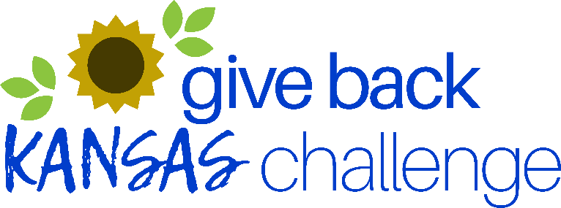
Social Media Sample Posts
- We are joining the Give Back Kansas Challenge from April 1 – May 31, 2024! Learn more at bit.ly/Givebackks. #Givebackks
- A company of 1 to a company of 10,000 - It doesn't matter the size to join the #Givebackks Challenge!
- Employer-supported volunteering leads to improved retention, well-being, and job satisfaction. Sign up for the #Givebackks Challenge and celebrate your employees!
- Our competitive spirit is ready for Give Back Kansas! We've joined the Challenge and invite you to learn more at bit.ly/Givebackks.
- XXXX's (company/organization) employees have already volunteered with over XX organizations in the first XX weeks of the #Givebackks Challenge!
- Our goal is to be #1 in the #Givebackks Challenge! Volunteering is vital to our community! Won't you join us?
- Bragging rights go to this year's #Givebackks challenge winner. How many hours can YOU volunteer?
- Right now, our employees have collectively volunteered xx hours for the #Givebackks challenge! What are YOU doing for your community? Join the challenge and make a difference.
- Volunteering is crucial to solving some of our state's biggest challenges. Sign up for the #Givebackks Challenge!
- Volunteer Kansas hosts an online website of statewide volunteer opportunities at www.volunteerkansas.org . You can search for activities you would enjoy there. If you live in a community with a Volunteer Center, you are encouraged to contact them for additional information on volunteer opportunities. Find your volunteer center at bit.ly/Givebackks.

