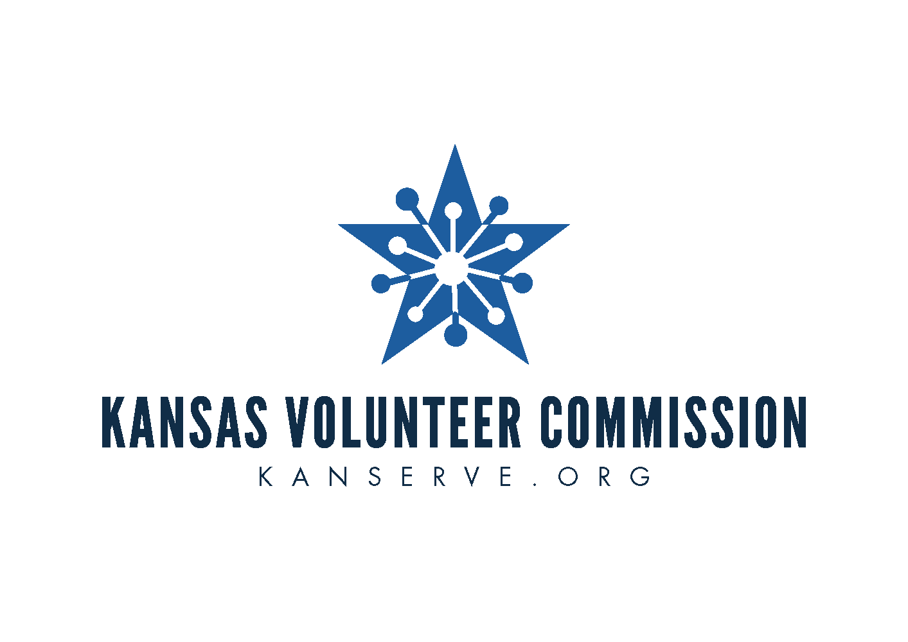
2023 – 2024 AmeriCorps Kansas
Notice of Funding Opportunity (NOFO)
Planning Grant

Deadline for Application Submission:
January 31, 2023
Via email to: AmeriCorps@ksde.org

For more information contact:
Kansas Volunteer Commission
785-368-6232
americorps@ksde.org

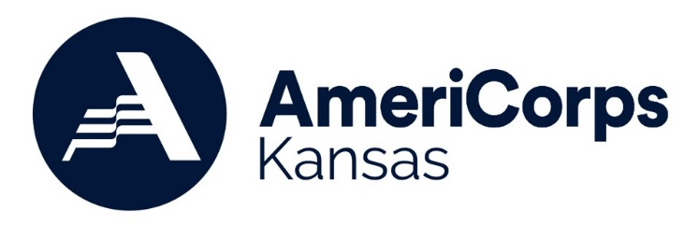

TABLE OF CONTENTS

A. PROGRAM DESCRIPTION 3
B. FEDERAL AWARD INFORMATION 6
C. ELIGIBILITY INFORMATION 6
D. APPLICATION AND SUBMISSION INFORMATION 7
E. APPLICATION FIELDS 9
F. APPLICATION REVIEW AND SELECTION PROCESS 11
G. FEDERAL AWARD ADMINISTRATION INFORMATION 11
H. CONTACT INFORMATION 12
I. PROHIBITED AND UNALLOWABLE ACTIVITIES 13

NOTICE of Funding Opportunity
Federal Agency Name: AmeriCorps
Issuing Agency Name: Kansas Volunteer Commission
Funding Opportunity Title: AmeriCorps Kansas Planning Grant 2023
Issue Date: October 10, 2022

This Notice of Funding Opportunity (NOFO) is for applicants interested in a 12-month planning period to develop an AmeriCorps Kansas program.

Applicants who review this NOFO and determine they would prefer an operational grant that includes AmeriCorps members, should refer to the AmeriCorps Kansas Operational Grant NOFO available at: https://kanserve.org/Grants-and-Funding/AmeriCorps-Kansas-Grant/AmeriCorps-Kansas-Operational-Grant.

Disclosure: Publication of this NOFO does not obligate AmeriCorps or the Commission to award any specific number of grants or to commit any particular amount of funding. Kansas Volunteer Commission reserves the right to re-focus program dollars for this competition in the event of disaster or other compelling needs.

Date | Activity
October 10, 2022 | AmeriCorps Kansas Planning Grant Notice of Funding Opportunity (NOFO) released
January 31, 2023 by 5:00PM | Final applications with revisions due to Commission
February 28, 2023 | Applicants receive clarification questions
March 17, 2023 by 5:00PM | Clarification question responses due to Commission
April 4, 2023 | Kansas Volunteer Commission votes on AmeriCorps portfolio
May 9, 2023 | Kansas State Board of Education votes on AmeriCorps portfolio
May 26, 2023 | Official AmeriCorps Kansas grant award notifications
August 1, 2023 | Program start date

A. PROGRAM DESCRIPTION

A.1 Purpose of AmeriCorps Funding
AmeriCorps Planning Grants enable organizations to plan a proposed AmeriCorps program and develop (or replicate) systems for successful implementation of an AmeriCorps operational grant application. Organizations use planning grants to become better prepared to compete for an AmeriCorps program grant in the subsequent grant cycle (2024-2025).

To assist applicants in understanding the time commitment and reporting required for this grant, the Commission encourages applicants to review the following documents:
- Planning Subgrant Timeline
- Planning Subgrant Calendar
- Planning Subgrant Manual

A key indicator of planning grants who have made the successful transition to operational grants, is providing sufficient staff capacity for the planning process. The Commission encourages applicants to include the cost of a staff person who will be the primary contact during the entire planning grant period and ideally will transition to implementing the AmeriCorps operational grant, if selected for funding. Because of this, the Commission strongly encourages planning applicants to budget at least 0.5 FTE to manage the planning grant.

Planning grants MAY NOT be used for costs associated with writing an AmeriCorps application. Planning grants DO NOT receive/provide AmeriCorps members. Examples of planning activities include (but is not limited to):
  - Hire a consultant to help with the planning process
  - Participate in training and technical assistance needed in order to plan and develop an effective, compliant AmeriCorps program
  - Determine the AmeriCorps member activities needed to address the identified community need
  - Determine the desired characteristics of AmeriCorps members and develop a recruitment strategy
  - Develop a data collection system, and explore performance measures, to ensure that accurate, timely, reliable data is gathered to demonstrate impact
  - Research evidence-based program models and determine which is most appropriate for this AmeriCorps program design
  - Create a process for selecting host sites (if applicable)

AmeriCorps
AmeriCorps is the federal grantmaking organization for all AmeriCorps programming nationally. AmeriCorps brings people together to tackle some of the country’s most pressing challenges through national service and volunteering. AmeriCorps members and AmeriCorps Seniors volunteers serve with organizations dedicated to the improvement of communities. AmeriCorps grants are awarded to eligible organizations proposing to engage AmeriCorps members in evidence-based or evidence-informed interventions/practices to strengthen communities.

Kansas Volunteer Commission (Commission)
The mission of the Commission is to empower all Kansans to meet community needs through service. The Commission, a program of the Kansas State Department of Education, directs effective national service programs, supports statewide mentoring efforts, and leads volunteer engagement training opportunities. AmeriCorps Kansas programs are funded from federal resources allocated to the Commission according to a formula based on state population. Each year, AmeriCorps notifies the Commission of the amount of formula funding available. In most years, the Commission does not have adequate funding to cover all requests.

A.2 Funding Priorities
The Commission’s priorities for this grant competition are
- COVID-19: Efforts that help local communities respond to and recover from the COVID-19 pandemic.
- Education: Efforts that support improved educational and behavioral outcomes, school readiness and/or preparation for success in postsecondary educational institutions.
- Poverty: Efforts that address the complexities of poverty, especially economic mobility as well as housing, food and health stability.
- Rural Intermediary: Organizations that serve as an umbrella for rural communities with limited resources and organizational infrastructure.
- Social Justice: Efforts that ensure equal rights and equitable opportunities for all.
- Youth Development & Mentoring: Efforts that empower youth through opportunities and support, positive relationships, and leadership development, particularly among youth in foster care.

To receive priority consideration, applicants must show that the priority area is a significant part of the program focus and intended outcomes. Programs that receive priority consideration are not guaranteed funding.

A.3 Technical Assistance
Applicants are highly encouraged to participate in an online technical assistance session via ZOOM on Friday, October 14, 2022 at 2:00pm CST to review application instructions and ask questions about the process. This call will be recorded and available at www.kanserve.org.
- Join Session: https://ksde.zoom.us/j/8819998747

In addition, applicants may request one-on-one consultation and technical assistance from Commission staff by emailing americorps@ksde.org before the application due date.

B. FEDERAL AWARD INFORMATION

B.1 Estimated Available Funds
The Commission expects a highly competitive AmeriCorps grant competition. Awards for planning grants may not exceed $50,000. Award amounts will vary, as determined by the scope of the projects.

Planning grants are awarded on a cost-reimbursement basis only. If awarded, subgrantees will submit monthly invoices, after expenses are incurred, as requests for reimbursement to the Commission. Only those expenses incurred after the grant starts are eligible for reimbursement. Subgrantees are required to match at 24 percent, either through cash or in-kind contributions.

B.2 Project and Award Period
The project period is August 1, 2023 – July 31, 2024. During the planning grant period, applicants will be notified of operational grant funding opportunities. The Commission will work with the applicant to determine competitions to apply for. Applying for an operational grant is not required, but applicants will be encouraged to move in that direction and coached on feasibility.

All applicants should be aware that it is prohibited for any Commission funded project to start activities prior to the award of the grant and signed agreements.

B.3 Program Authority
Awards under this NOFO are authorized by the National and Community Service Act of 1990, as amended, (42 U.S.C. § 12501 et seq.).

C. ELIGIBILITY INFORMATION

C.1 Eligible Applicants
The following entities are eligible to apply. Receiving funding previously from AmeriCorps or another Federal agency is not a prerequisite to apply under this NOFO:
- Public or private nonprofit organizations, including faith-based and other community organizations
- Federally Recognized Tribes
- Institutions of higher education and school districts
- Government entities within the state (e.g. cities and counties)

C.2 System for Award Management (SAM)
All applicants must register with the System for Award Management (SAM) at https://www.sam.gov/SAM/ to receive a Unique Entity Identifier (UEI). The applicant must have an active SAM registration throughout the duration of the award. SAM registration must be renewed annually.

The Commission suggests that applicants finalize a new registration or renew an existing one at least six weeks before the application deadline, to allow time to resolve any issues that may arise. Applicants must use their SAM-registered legal name and address on all grant applications to Commission. The Commission will not make awards to entities that do not have a valid SAM registration. If an applicant has not fully complied with these requirements by the time Commission is ready to make an award, the Kansas Volunteer Commission may determine that the applicant is not qualified to receive an award and use that determination as a basis for making an award to another applicant.

C.3 Other Eligibility Requirements
Under Section 132A(b) of the National and Community Service Act of 1990, as amended, organizations that have been convicted of a federal crime may not receive assistance described in this NOFO. Applications that propose to engage in activities that are prohibited or unallowable under AmeriCorps’s statutes, regulations, or the terms and conditions of its awards are not eligible to receive Commission funding (see Section ). Pursuant to the Lobbying Disclosure Act of 1995, an organization described in Section 501(c)(4) of the Internal Revenue code of 1986, 26 U.S.C. § 501(c)(4), that engages in lobbying activities is not eligible to apply for Commission funding.

D. Application and Submission InformaTion
This NOFO should be read together with the AmeriCorps Regulations, 45 CFR 2520–2550 and the Budget instructions, which are incorporated by reference. These documents can be found on https://kanserve.org/Grants-and-Funding/AmeriCorps-Kansas-Grant/AmeriCorps-Kansas-Planning-Grant. The full Regulations are available online at www.ecfr.gov.

D.1 Application Deadline
All application materials are due no later than Tuesday, January 31, 2023 by 5 pm CST via email to americorps@ksde.org

The Commission will not accept applications that are late, mailed or faxed. Applicants will not be asked to enter their applications into eGrants (the federal grant system) until after award decisions have been made.

The Commission encourages applicants to be concise but thorough. Applicant should also avoid usage of styling formatting features included but not limited to (bold, underline, tabs, outlines, bulleted lists, smart quotes, hyperlinks etc.). The Commission reserves the right to extend submission deadline and any notice of such extended deadline will be posted to apply to all applicants.

D.2 Application Content

Narratives (written in a word document):
- Program Design
- Organizational Review
- Budget Narrative

Attachments:
- Cover Letter Worksheet
- Budget Worksheet

D.3 Application Page Limits
Applications may not exceed 6 pages for the Narratives. The application page limit does not include the Cover Letter or Budget Worksheets. In determining whether an application complies with page limits, the Commission will count the following as narrative:
- Program Design
- Organizational Review
- Budget Narrative

D.4 Submission of Additional Documents
Applicants are required to submit the following additional documents by the application submission deadline, by emailing AmeriCorps@ksde.org:
- Operational and Financial Management Survey (OFMS). Please submit the OFMS as a Word document. Forms submitted as a PDF or any other document format may not be accepted
- W-9 Form
- Most recent single audit (entities subject to 2 CFR 200 Subpart F); OR most recent audited financial statements; OR an explanation as to why neither are available

Entities applying on behalf of a Federally Recognized Tribe
- Tribal organization eligibility documentation

E. APPLICATION FIELDS
The Commission urges applicants to submit high quality applications that carefully follow the guidance in this NOFO. The quality of an application will be an important factor in determining whether an organization will receive funding.

Categories/Subcategories | Percentage
Program Design | 70
Funding Priority | 5
Need | 15
Program Model | 25
Planning Process | 25
Organizational Review | 20
Organization Capacity | 10
Fiscal Oversight | 10
Budget Narrative | 10

E.1 Program Design (70 points)
Funding Priority (5 points)
- Describe how the proposed program ties into one or more funding priority areas (leave blank if not applicable).

Need (15 points)
- Describe in detail the community need and target population the proposed program will address. Provide a brief summary of specific evidence to support the need for your proposed AmeriCorps program. Cite sources within the last five years from your local community.

Program Model (25 points)
Describe your plans for an operational AmeriCorps program. While the planning grant will help to determine specifics of the program, applicants should include as much information as possible about the potential AmeriCorps program as they currently imagine it.
- Explain how AmeriCorps members are a highly effective means to solve the identified community problem.
- Describe where you expect AmeriCorps members to serve (list the counties as well as specific organizations, if known).
- Describe the activities that AmeriCorps members will be engaged in (the intervention) and how those activities will connect to the identified community need(s).
- Describe how the AmeriCorps members will be supervised.
- Describe how the AmeriCorps members will be supported by the organization and the skills they will obtain during service.
- Provide an estimate of how many AmeriCorps members your program would support and whether they would serve on a full-time or part-time basis. Note: AmeriCorps Kansas prefers to fund programs that engage at least three full-time members (or a combination of part-time members) each year.

Planning Process (25 points)
- Describe the planning process with timeline and benchmarks for planning activities and how you will use the planning period to develop your capacity to effectively manage an AmeriCorps program.
- Describe how the planning period will be used to engage community members, organizations, stakeholders and potential partners in the planning grant process.

E.2 Organizational Review (20 Points)
Organization Capacity (10 Points)
- Who will be the lead staff managing this initiative? Explain why they are qualified to lead the organization through this project.
- What infrastructure has the program developed to ensure effective project oversight?
- Provide examples of your organization’s prior experience administering similar projects or programs.
- Discuss the level of buy-in or organizational commitment your executive leadership and community partners have for this project.

Fiscal Oversight (10 points)
- Describe the demonstrated experience your organization has in managing grants.
- What infrastructure have you developed to ensure effective fiscal oversight?
- What experience does your organization have managing federal and non-federal grants?
- How will you ensure compliance with grant requirements?

E.3 Budget Narrative (10 Points)
In addition to the budget narrative, applicants must also submit the Budget Worksheet (see Budget Instructions for more details).
- Describe the amount and sources of match that have been secured to date, and any plans to secure additional match by the project start date if needed.
- Describe your plans to develop a cost-effective program, including how you will develop diverse resources that will support your program implementation and sustainability.

E.4 Performance Measures
Performance Measures are NOT required for planning grants. Planning subgrantees will be expected to follow AmeriCorps Kansas guidance and reach benchmarks throughout the project/award period. If selected, subgrantees will receive training and technical assistance opportunities throughout the project/award period.

F. APPLICATION REVIEW AND SELECTION PROCESS
The assessment of applications involves a wide range of factors and considerations. The Commission will engage external reviewers to provide insight and input with respect to eligible applications. In addition, Commission staff will apply their experience and expertise in evaluating applications. In the end, the review and selection process will produce a diversified set of high-quality programs that represent the priorities and strategic consideration described in this NOFO. Applicants will be selected based upon quality of application and demonstrated need. The stages of the review and selection process are as follows:
- Applicants will submit application by January 31, 2023.
- Grant review committee will review final applications and develop clarification questions.
- Applicants will receive clarification questions by February 28, 2023.
- Applicants will respond to clarification questions by March 17, 2023.
- Grant review committee will review clarification responses and make funding recommendations.
- Kansas Volunteer Commission will vote on AmeriCorps portfolio on April 4, 2023.
- Kansas State Department of Education will vote on AmeriCorps portfolio on May 9, 2023.

F.2 Federal Award Notices
The Commission will make awards following the grant selection announcement. Kansas Volunteer Commission anticipates announcing the results of this competition by May 25, 2023 contingent on the availability of congressional appropriations. All applicants, successful or not, will be notified of funding decisions via email. Notification of an award is not an authorization to begin grant activities. The Subgrant Agreement is the authorizing document for grant activities. An awardee may not expend federal funds until the start of the Project Period identified on the Subgrant Agreement.

G. FEDERAL Award Administration Information
G.1 Uniform Guidance
All awards made under this NOFO will be subject to the Uniform Administrative Requirements, Cost Principles, and Audit Requirements for Federal Awards (Uniform Guidance) in 2 CFR Parts 200 and 2205.

G.2 AmeriCorps Terms and Conditions
All awards made under this NOFO will be subject to the FY 2023 AmeriCorps General Terms and Conditions and the FY 2023 AmeriCorps Program Specific Terms and Conditions. These Terms and Conditions contain detailed, mandatory compliance and reporting requirements. Current versions of the AmeriCorps General and Program Specific Terms and Conditions for each of its programs is available at State subgrantees | AmeriCorps.

G.3 National Service Criminal History Check Requirements
Planning grants are not required to complete National Service Criminal History Checks.

G.4 Official Guidance
All AmeriCorps active Guidance is available on the agency’s Guidance webpage: https://www.americorps.gov/about/agency-overview/official-guidance. The contents of these documents do not have the force and effect of law and are not meant to bind the public in any way unless incorporated into a contract or grant agreement. These documents are intended only to provide clarity to the public regarding existing requirements under the law or agency policies.

G.5 Use of Material
To ensure that materials generated with AmeriCorps funding are available to the public and readily accessible to recipients and non-recipients, AmeriCorps reserves a royalty-free, nonexclusive, and irrevocable right to obtain, use, modify, reproduce, publish, or disseminate publications and materials produced under the award, including data, and to authorize others to do so (2 CFR §200.315).

G.6 Reporting
Award recipients are required to submit a variety of reports which are due at specific times during the life cycle of an award. All reports must be accurate, complete, and submitted on time. Award recipients are also required to attend scheduled progress calls and shall participate fully in any state-sponsored training and leadership events regarding the AmeriCorps Program, such as the AmeriCorps Leadership Summit in the fall, as designated by the Kansas Volunteer Commission.

H. CONTACT INFORMATION
Please submit questions about this funding opportunity to Commission staff listed below. We will attempt to answer all questions in a timely manner; however, we cannot guarantee effective or efficient responses near the deadline. If you require an accommodation, such as language translation or cultural translation technical assistance, please email your specific request to americorps@ksde.org.

For financial questions
Jessica Dorsey
Executive Director
Email: jdorsey@ksde.org
For all other questions
Kay Emerson
AmeriCorps Kansas Director
Email: kemerson@ksde.org

I. PROHIBITED AND UNALLOWABLE ACTIVITIES

Prohibited Activities
While charging time to the AmeriCorps program, accumulating service or training hours, or otherwise performing activities supported by the AmeriCorps program or AmeriCorps, staff and members may not engage in the following activities (see 45 CFR § 2520.65):
- Attempting to influence legislation;
- Organizing or engaging in protests, petitions, boycotts, or strikes;
- Assisting, promoting, or deterring union organizing;
- Impairing existing contracts for services or collective bargaining agreements;
- Engaging in partisan political activities, or other activities designed to influence the outcome of an election to any public office;
- Participating in, or endorsing, events or activities that are likely to include advocacy for or against political parties, political platforms, political candidates, proposed legislation, or elected officials;
- Engaging in religious instruction, conducting worship services, providing instruction as part of a program that includes mandatory religious instruction or worship, constructing or operating facilities devoted to religious instruction or worship, maintaining facilities primarily or inherently devoted to religious instruction or worship, or engaging in any form of religious proselytization;
- Providing a direct benefit to— a. a business organized for profit; b. a labor union; c. a partisan political organization; d. a nonprofit organization that fails to comply with the restrictions contained in section 501(c)(3) of the Internal Revenue Code of 1986 related to engaging in political activities or substantial amount of lobbying except that nothing in these provisions shall be construed to prevent participants from engaging in advocacy activities undertaken at their own initiative; and e. an organization engaged in the religious activities described in paragraph C. 7. above, unless AmeriCorps assistance is not used to support those religious activities;
- Conducting a voter registration drive or using AmeriCorps funds to conduct a voter registration drive;
- Providing abortion services or referrals for receipt of such services; and
- Such other activities as AmeriCorps may prohibit.

AmeriCorps members may not engage in the above activities directly or indirectly by recruiting, training, or managing others for the primary purpose of engaging in one of the activities listed above. Individuals may exercise their rights as private citizens and may participate in the activities listed above on their own initiative, on non-AmeriCorps time, and using non- AmeriCorps funds.

Unallowable Activities
In addition to the Prohibited Activities, the following restrictions also apply to the service of AmeriCorps members:
- Nonduplication:
AmeriCorps assistance may not be used to duplicate an activity that is already available in the locality of a program. AmeriCorps assistance will not be provided to a private nonprofit entity to conduct activities that are the same or substantially equivalent to activities provided by a State or local government agency in which such entity resides unless the entity complies with the following “nondisplacement” requirements.
- Nondisplacement:
  - An employer may not displace an employee or position, including partial displacement such as reduction in hours, wages, or employment benefits, as a result of the use by such employer of a participant in a program receiving AmeriCorps assistance.
  - An organization may not displace a volunteer by using a participant in a program receiving AmeriCorps assistance.
  - A service opportunity will not be created under this chapter that will infringe in any manner on the promotional opportunity of an employed individual.
  - A participant in a program receiving AmeriCorps assistance may not perform any services or duties or engage in activities that would otherwise be performed by an employee as part of the assigned duties of such employee.
  - A participant in any program receiving assistance may not perform any services or duties, or engage in activities, that—
    - Will supplant the hiring of employed workers; or
    - Are services, duties, or activities with respect to which an individual has recall rights pursuant to a collective bargaining agreement or applicable personnel procedures.
  - A participant in any program receiving assistance may not perform services or duties that have been performed by or were assigned to any—
    - Presently employed worker;
    - Employee who recently resigned or was discharged;
    - Employee who is subject to a reduction in force or who has recall rights pursuant to a collective bargaining agreement or applicable personnel procedures;
    - Employee who is on leave (terminal, temporary, vacation, emergency, or sick); or
    - Employee who is on strike or who is being locked out.

