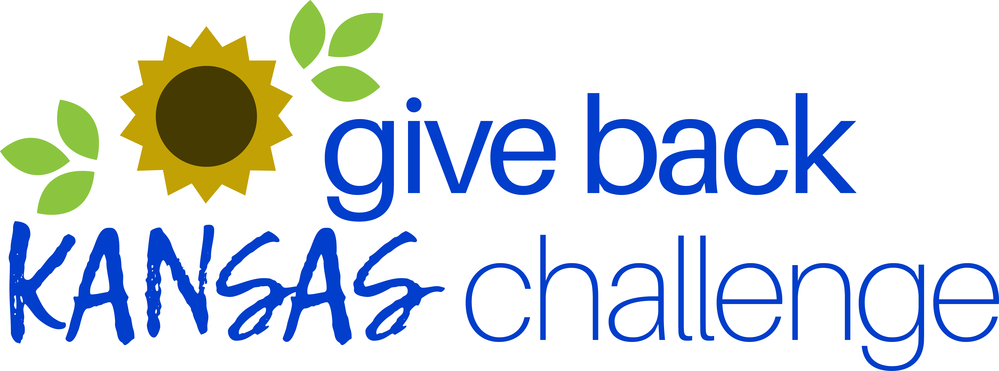

Join the Challenge!
April 17 – June 9

Dear <COMPANY NAME> employees,

We are excited to announce our participation in the annual Give Back Kansas Challenge! The Challenge was created for employers to encourage their employees to engage in community volunteering. This eight-week competition runs from April 17 – June 9, 2023. We urge you to volunteer and track your hours, so we can win this Challenge!

Research shows that employees who volunteer experience greater engagement, organizational commitment, and greater job satisfaction.

The Give Back Kansas Challenge is a great opportunity for our company to receive recognition for volunteer hours, as well as for our employees to try something new that could develop new skills or enthusiasm for your work.

We invite you to participate in the Give Back Kansas Challenge. Employers with the highest average number of volunteer hours per employee during the Challenge will be recognized and a $1,000 grant from Volunteer Kansas will be given to the charity of their choice. So get your competitive spirit in gear!

Challenge information and resources on how to participate and find volunteer opportunities in the community are provided at https://kanserve.ksde.org/take-action/partner-with-us/give-back-kansas-challenge

ARE YOU IN?

Please contact <COMPANY CONTACT NAME> at <EMAIL> to learn more and participate.

