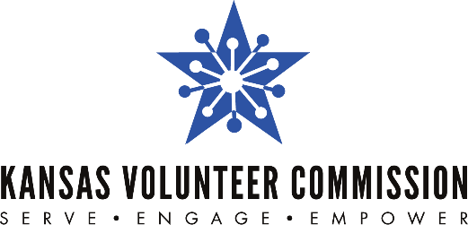

For Immediate Release Contact:
Feb. 3, 2022 Jessica Dorsey, (785) 296-3163
jdorsey@ksde.org

EDITOR’S NOTE: The Kansas Volunteer Commission shouldn’t be shortened to KVC. It should be written out as Kansas Volunteer Commission.

Employers invited to join
Give Back Kansas Challenge
Challenge encourages employer-supported volunteering

WICHITA/TOPEKA – Kansas employers are invited to register for the second annual Give Back Kansas Challenge and encourage their employees to participate in community volunteering.

The eight-week Challenge runs from April 18 through June 10, 2022. Participants need to register at bit.ly/Givebackks by April 1, 2022.

The Give Back Kansas Challenge is an opportunity for employees who volunteer regularly to receive recognition by tracking and reporting their hours. Employees who are new to volunteerism will be encouraged to try something new that could help them develop additional skills or enthusiasm for their work or community.

“The Challenge will be a fun and exciting way for participants to learn more about organizations in their communities and help them out by giving of their time and abilities,” said Nola Brown, executive director of Volunteer Kansas, which is partnering with the Kansas Volunteer Commission to promote the Challenge to Kansans.

There is no cost to participate, and the Challenge is open to any employer in Kansas (for profit, nonprofit, and government). Employers register in advance to participate, and volunteer hours are reported through an online portal by the employers’ self-designated point of contact.

Based on the number of entries received and company size, employers will be divided into three categories (large, medium and small). Winners of the challenge will be selected by determining the average number of volunteer hours per employer completed during the challenge period. Employers achieving the highest average in each size category will have a $1,000 donation made on their behalf by Volunteer Kansas to the charity of their choice. Those employers will be invited to a check presentation ceremony.

“Research shows that employer-supported volunteering can result in improved employee engagement, organizational commitment, job satisfaction and retention,” said Jessica Dorsey, executive director of the Kansas Volunteer Commission. “We look forward to seeing the many positive ways that participating organizations are affected during the Give Back Kansas Challenge.”

Complete information and resources on how to participate and find volunteer opportunities are available at bit.ly/Givebackks or by contacting Jessica Dorsey at jdorsey@ksde.org or 785-296-3163.

###

The Kansas Volunteer Commission is a program of the Kansas State Department of Education (KSDE). The mission of the Kansas Volunteer Commission is to empower all Kansans to meet community needs through service. The Commission's primary role is to provide resources and leadership to support local initiatives that tackle community needs. As the state service commission, the Kansas Volunteer Commission directs effective national service programs, provides volunteer management training opportunities and supports the work of Mentor Kansas. For more information, visit www.kanserve.org.

Volunteer Kansas Inc. is a 501(c)(3) charity based in Wichita, Kansas. www.Volunteerkansas.org is the organization’s website devoted to increasing volunteerism in the state of Kansas and providing a hub for Kansans to find other Kansans who may need volunteer or material help. The website is a free service to individuals and organizations.

