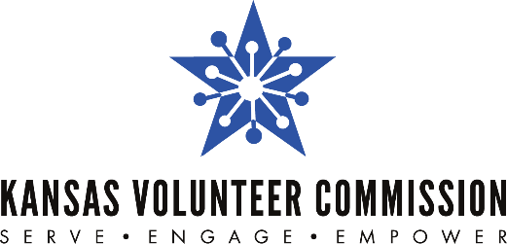

FOR IMMEDIATE RELEASE CONTACT: Jessica Noble
7/28/2022 (785) 296-3163 | jnoble@ksde.org

Kansas Volunteer Commission Selects Six Kansas Nonprofits to Join the 2022 Service Enterprise Initiative
Organizations will bolster their volunteer programs by completing the prestigious Service Enterprise change management certification process

TOPEKA, Kansas - In July 2019, the Kansas Volunteer Commission became the first Service Enterprise (SE) Certified organization in Kansas through a process lead by Points of Light, the world’s largest volunteer service organization. While obtaining this credential, the Commission also trained to become the SE training hub for the state.

As a training hub, the Commission now leads other organizations through the prestigious SE certification process, a professional development process that trains organizations to strategically leverage volunteers in a way that encourages them to more effectively and efficiently meet their organizational mission.

The Commission is excited to announce that six organizations have been selected to join the 2022 Kansas Service Enterprise Initiative to work toward achieving their SE certification. Funding for this certification process is provided by AmeriCorps, the federal agency for national service and community volunteerism.

If successful, the organizations selected to go through the certification process will join the top 11 percent of nonprofits nationwide that have earned this honor in volunteer management and organizational performance. A SE certification will put the following organizations at the forefront of volunteer development for the state:

- Butler County Department on Aging RSVP and Foster Grandparents
- Johnson County Christmas Bureau
- LiveWell Douglas County
- Medical Reserve Corps of Greater Kansas City
- Newton Et Cetera Shop Inc.
- OZ Museum/Columbian Theater Foundation, Inc.

Executive Director, Jessica Noble, says, “The Service Enterprise certification process will give the selected organizations a framework and pathway to build capacity by incorporating volunteers at all levels of their work.”

Research conducted by the TCC Group, a national program and evaluation firm, found that organizations operating as Service Enterprises outperform peer organizations on all aspects of organizational effectiveness, and are more adaptable, sustainable and capable of scaling their work. In fact, 80% of Service Enterprise organizations report an increase in both volunteer and skill-based volunteers.

The SE Initiative is a national change management program that helps organizations gain a greater return on volunteer investment to better achieve their mission. Training for the 2022 cohort will begin on August 4th. For more information, please visit www.kanserve.org

Editor Note: The Kansas Volunteer Commission should be referred to by its full name or called “The Commission”. It should NOT be referred to as KVC, as that is another organization in Kansas.

###

The Kansas Volunteer Commission is a program of the Kansas State Department of Education (KSDE). The mission of the Kansas Volunteer Commission is to empower all Kansans to meet community needs through service. The Commission's primary role is to provide resources and leadership to support local initiatives that tackle community needs. As the state service commission, the Commission directs effective national service programs, provides volunteer management training opportunities and supports the work of Mentor Kansas. For more information, visit www.kanserve.org.

AmeriCorps is the federal agency for volunteering, service and civic engagement. The agency engages millions of Americans in citizen service through its AmeriCorps and AmeriCorps Seniors programs and leads the nation's volunteering and service efforts. For more information, visit www.AmeriCorps.gov.

