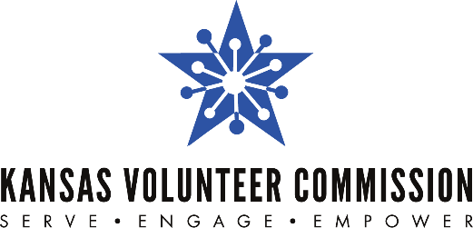

For Immediate Release Contact:
Jan. 11, 2022 Jessica Noble, (785) 296-3163
jnoble@ksde.org

EDITOR’S NOTE: The Kansas Volunteer Commission shouldn’t be shortened to KVC. It should be written out as Kansas Volunteer Commission.

Kansas Volunteer Commission,
volunteer agencies build capacity in Kansas
Funds provided through Volunteer Generation Fund used to support Kansas volunteerism

TOPEKA – The Kansas Volunteer Commission has awarded a total of $122,276 to seven Kansas volunteer and mentor organizations through the 2022 Kansas Volunteer Generation Fund (VGF) grant competition.

Each organization will receive between $15,000 and $20,000 for one year.

The Commission received the VGF grant from AmeriCorps, the federal agency that oversees the nation’s volunteer initiatives.

The Commission was granted 2022 AmeriCorps Volunteer Generation Fund (VGF) dollars to expand the capacity of Kansas community-based entities that effectively use volunteers and mentors as catalysts to address critical community issues.

“The Kansas Volunteer Commission is proud to support the Kansas VGF recipients with funding, training and technical assistance that has been proven to increase capacity," said Jessica Dorsey, Kansas Volunteer Commission executive director.

2022 Kansas Volunteer Generation Fund Grant recipients are:
- CASA of the 17th Judicial District Inc. – Serving Decatur, Graham, Norton, Osborn, Phillips and Smith counties.
- Cross-Lines Community Outreach Inc. – Serving Wyandotte County.
- Douglas County CASA Inc. – Serving Douglas County.
- Flint Hills Volunteer Center – Serving Geary, Pottawatomie and Riley counties.
- Peace Connections Inc. – Serving Harvey, Sedgwick, Butler, McPherson and Pratt counties.
- Rosedale Development Association – Serving Kansas City, Kansas.
- United Way of Greater Topeka – Serving Shawnee County.

These Kansas VGF subgrantees will increase the infrastructure and expand the capacity of volunteer and mentoring organizations as they work with volunteers to improve their communities.

In 2021, the Commission awarded a total of $120,000 to eight Kansas volunteer and mentor organizations. The 2021 Kansas Volunteer Generation Fund Grant recipients were Douglas County CASA Inc.; Flint Hills Volunteer Center; Heart of a Champion/One Heart Project; Kansas Humane Society; Peace Connections Inc.; Rosedale Development Association; United Way of Douglas County; and United Way of Franklin County Association.

VGF’s unique model means that the grants announced will leverage additional public and private funds – further increasing the return on the federal investment. The Commission anticipates that the 2022 grants will leverage an additional $122,276.

###

The Kansas Volunteer Commission is a program of the Kansas State Department of Education (KSDE). The mission of the Kansas Volunteer Commission is to empower all Kansans to meet community needs through service. The Commission's primary role is to provide resources and leadership to support local initiatives that tackle community needs. As the state service commission, the Commission directs effective national service programs, provides volunteer management training opportunities and supports the work of Mentor Kansas. For more information, visit www.kanserve.org.

