Performance Measure Instructions

Public Health AmeriCorps

2023

Table of Contents
Public Health AmeriCorps Performance Measure Requirements 3
CAPACITY BUILDING 4
HEALTHY FUTURES 5
Appendix A: Understanding MSY and Member Allocations 6
Appendix B: Performance Measures Checklist 10
Appendix C: Frequently Asked Questions 12

Public Health AmeriCorps Performance Measure Requirements
Each applicant is required to select at least one aligned performance measure (output paired with outcome) that corresponds to the proposed primary service activity. Each applicant must choose from the following National Performance Measures:

Focus Area | Objective | Selection Rules |  | Interventions
 |  | Outputs | Outcomes
Healthy Futures | Access to Care | H4A: Number of individuals served | H17: Number of individuals with increased health knowledge  H18: Number of individuals reporting a change in behavior or intent to change behavior to improve their health  H19: Number of individuals with improved health  H20: Number of individuals with improved access to medical care | Outreach  Education/Training  Referrals  Medical Services  Counseling/Coaching  Opioid/Drug Intervention/Harm Reduction  Navigation of Services  COVID Response/COVID Recovery
Capacity Building | Capacity Building & Leverage | G3-3.4: Number of organizations that received capacity building services | G3-3.10A: Number of organizations that increase their efficiency, effectiveness, and/or program reach*  * Each applicant must describe in detail how it will measure the organizational effectiveness, efficiency, or program scale/reach in meeting the public health needs of the community in the Described Instrument section. | Disaster Preparation  Disaster Response  Disaster Recovery  Disaster Mitigation

All performance measures must reflect significant program activities whose outputs and outcomes are consistent with the applicant’s core theory of change. Applicants are not expected to have performance measures for every program activity.

All performance measures must be associated with one or more interventions (service activities). Applicants are expected to use the system-defined intervention categories if they appropriately represent the applicant’s program activities. Applicants may not create user-defined intervention labels that duplicate existing intervention categories.

CAPACITY BUILDING
Focus Area Notes
- Programs should only opt into the Capacity Building performance measures if the measures reflect significant program activities aligned with the applicant’s core theory of change.
- Activities associated with these measures must be carried out by National Service Participants or by volunteers directly recruited and/or supported by National Service Participants.
- Activities associated with these measures must meet the definition of capacity building specified in the “key terms” definition under G3-3.4.
- Programs are not permitted to create applicant-determined outputs in the Capacity Building focus area.

G3-3.4 (output) | Number of organizations that received capacity building services
Definition of Key Terms | Organization: nonprofit or state/local/tribal government entity  Capacity building services: a set of activities that expand the scale, reach, efficiency, or effectiveness of programs and organizations. Capacity building activities may also leverage resources (e.g., funding, volunteers, in-kind support, or partnerships) for programs and/or organizations. As a general rule, AmeriCorps considers capacity building activities to be indirect services that enable organizations to provide more, better and sustained direct services. Capacity building activities must (1) be intended to support or enhance the program delivery model, (2) respond to the organization’s goal of increasing, expanding or enhancing services in order to address pressing community needs, and (3) enable the organization to provide a sustained level of more or better direct services after the national service participant’s term of service has ended.
How to Measure/  Collect Data | Tracking mechanism that ensures an unduplicated count of organizations who have received services

G3-3.10A (outcome) | Number of organizations that increased their effectiveness, efficiency, and/or program scale/reach
Definition of  Key Terms | Organizations: those counted in G3-3.4  Effectiveness: Improved ability of the organization to achieve outcomes resulting in better success rates or better quality of outcomes achieved  Efficiency: Improved outcomes with the same level of resources; improved or consistent quality of services with fewer resources  Scale/Reach: The scope of a program’s services. Increased scale/reach can be measured by the number of new people served, new populations served, and/ or new or expanded services.
How to Measure/  Collect Data | Organizational assessment tool or other instrument capable of measuring changes in effectiveness, efficiency, or scale/reach at the organization level. When possible, pre-post assessments should be utilized.

HEALTHY FUTURES

Focus Area Notes
- Programs should only opt into the Healthy Futures performance measures if the measures reflect significant program activities aligned with the applicant’s core theory of change.
- All individuals counted under these measures must be program beneficiaries, not National Service Participants. National Service Participant outputs and outcomes should be reported in the Performance Data Elements in annual Progress Reports.
- Activities associated with these measures must be carried out by National Service Participants or by volunteers directly recruited and/or supported by National Service Participants.

H4A (output) | Number of individuals served
Definition of  Key Terms | Individuals: recipients of AmeriCorps-supported services related to improving health-related outcomes  Served: substantive engagement of individuals with a specific health-related goal in mind. Cannot consist solely of mass dissemination of information such as email blasts, social media posts, or distributing pamphlets.
How to Measure/  Collect Data | Tracking mechanism that ensures an unduplicated count of individuals who have received services

H17 (outcome) | Number of individuals with increased health knowledge
Definition of  Key Terms | Individuals: those reported in H4A, V1, V7A, or V8
How to Measure/  Collect Data | Survey, test, or other instrument capable of measuring changes in knowledge at the individual beneficiary level. When possible, pre-post assessments should be utilized.

H18 (outcome) | Number of individuals reporting a change in behavior or intent to change behavior to improve their health
Definition of  Key Terms | Individuals: those reported in H4A, V1, V7A, or V8
How to Measure/  Collect Data | Survey, interview, or other instrument capable of measuring changes in behavior at the individual beneficiary level. When possible, pre-post assessments should be utilized.

H19 (outcome) | Number of individuals with improved health
Definition of  Key Terms | Individuals: those reported in H4A, V1, V7A, or V8
How to Measure/  Collect Data | Assessment by a healthcare professional, survey, or other instrument capable of measuring changes in health condition at the individual beneficiary level. When possible, pre-post assessments should be utilized.

H20 (outcome) | Number of individuals with improved access to medical care
Definition of  Key Terms | Individuals: those reported in H4A, V1, V7A, or V8
How to Measure/  Collect Data | Survey, interview, caseworker assessment, or other instrument capable of measuring changes in health care access at the individual beneficiary level. When possible, pre-post assessments should be utilized.

Appendix A: Understanding MSY and Member Allocations

How to Calculate MSY and Member Allocations

In the performance measure module, applicants enter the total share of program resources (MSYs and members) that will be directed to each objective. Member and MSY allocations entered in the application should be the program’s best estimate of how member time will be allocated.

The charts below show how a sample program could calculate its MSY allocations for different member types and different percentages of member time spent per objective. In this example, the program has a total of 135 members representing a variety of different slot types. All members spend at least some of their time contributing to the K-12 Success objective. The program’s full-time and half-time members also spend time contributing to the School Readiness objective: 50% of their time for full-time members and 20% for half-time members.

Objective #1: K-12 Success
Type of Member | MSY Multiplier for Type | x | Number of Members for Type | x | % of Member Time for Objective | = | MSY Allocation
FT | 1 | x | 100 | x | .50 | = | 50
TQT | .7 | x | 0 | x | 0 | =
HT | .5 | x | 5 | x | .80 | = | 2
RHT | .3809524 | x | 10 | x | 1.00 | = | 3.81
QT | .26455027 | x | 10 | x | 1.00 | = | 2.65
MT | .21164022 | x | 10 | x | 1.00 | = | 2.17
AT | .05627705 | x | 0 | x | 0 | =
Total Members |  |  | 135 | Total MSYs |  |  | 60.63

Objective #2: School Readiness
Type of Member | MSY Multiplier for Type | x | Number of Members for Type | x | % of Member Time for Objective | = | MSY Allocation
FT | 1 | x | 100 | x | .50 | = | 50
TQT | .7 | x | 0 | x | 0 | =
HT | .5 | x | 5 | x | .20 | = | .5
RHT | .3809524 | x | 10 | x | 0 | =
QT | .26455027 | x | 10 | x | 0 | =
MT | .21164022 | x | 10 | x | 0 | =
AT | .05627705 | x | 0 | x | 0 | =
Total Members |  |  | 105 | Total MSYs |  |  | 50.5

How It Looks on the MSY Tab

The program enters the total number of MSYs and members for each objective on the MSY/Members tab of the performance measures module. The system automatically calculates the percentage of MSYs allocated to each objective.
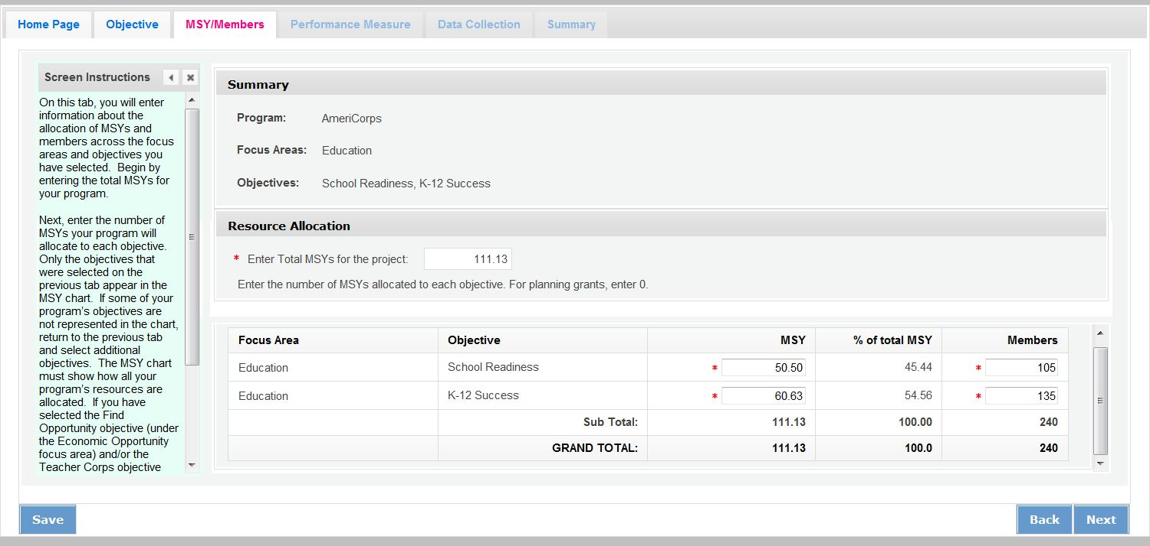

Note: Programs that select the Find Opportunity objective (Economic Opportunity Focus Area) or the Teacher Corps objective (Education Focus Area) must enter 0 MSYs and members for these objectives and allocate their MSYs to other objectives. This is because the MSY allocations are designed to show how programs’ resources are allocated to activities that benefit the community. The Find Opportunity and Teacher Corps objectives are focused on benefits to members.

How It Looks in the 424 PDF

Table 1 and its corresponding pie chart show the total number of MSYs by Focus Area. Since both the K-12 Success and School Readiness objectives are in the Education Focus Area, Table 1 shows 100% of MSYs in Education.
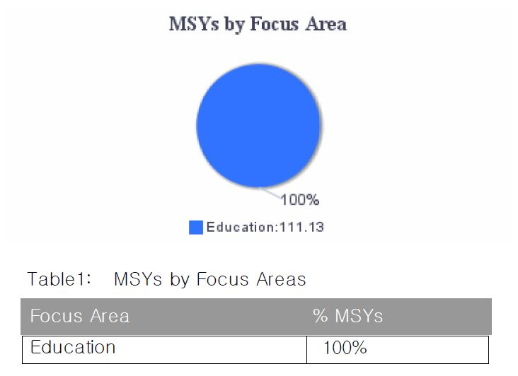
Table 4 in the PDF report shows the number of MSYs and members allocated to each objective, as seen on the MSY/Members tab:

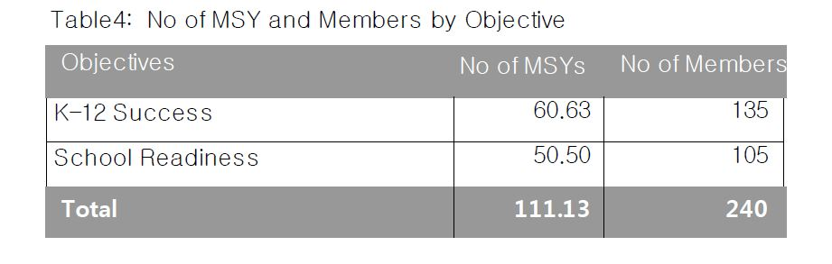
Because some members are performing service related to both K-12 Success and School Readiness, the total number of members listed in this table (240) is greater than the total number of slots the program is requesting (135). This is OK; individual members can be counted more than once if they contribute to more than one objective. In contrast, MSYs cannot be counted more than once, because they represent the amount of member time spent on a particular objective. As a result, the total number of MSYs listed in this table must be equal to the total MSYs the program is requesting (111.13).

Table 2 and its corresponding pie chart show the same MSY information expressed as percentages of the total MSYs:
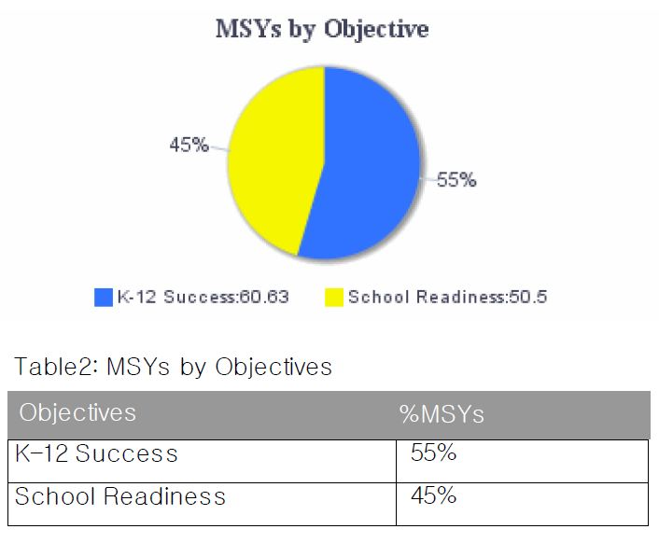
How to Assign MSYs to Performance Measures

When a program creates a performance measure, it must indicate how many MSYs and how many members will contribute to the measure. Based on the MSY allocations already entered for the sample program, the program may allocate up to 60.63 MSYs to K-12 Success performance measures and up to 50.5 MSYs to School Readiness performance measures. However, programs are not required to measure all of their activities, so it is possible that not all of these MSYs will be allocated to performance measures.

Our sample program has three performance measures, one (an aligned measure) under the K-12 Success objective and two (an output-only measure and an applicant determined measure) under the School Readiness objective.

Objective #1: K-12 Success
Intervention | Performance Measure | Percent of K-12 Success Time Spent on Activities that Contribute to this Measure | x | Total MSYs in Objective | = | MSYs Allocated to Performance Measure
Mentoring* | ED1A, ED27C | .75 | x | 60.63 | = | 45.47
Family Involvement | No Performance Measure | .25 | x | 60.63 |  | NA
*This is the primary intervention

Objective #2: School Readiness
Intervention | Performance Measure | Percent of School Readiness Time Spent on Activities that Contribute to this Measure | x | Total MSYs in Objective | = | MSYs Allocated to Performance Measure
Other Classroom Support | ED1A | .75 | x | 50.5 | = | 37.88
Parent Engagement | Applicant-Determined Measure | .25 | x | 50.5 | = | 12.62

How It Looks in the 424 PDF

Table 3 and its corresponding pie chart in the 424 PDF report shows the percentage of MSYs allocated to National Performance Measures, applicant-determined performance measures, or no performance measures. As seen in the table above, the program has two National Performance Measures (ED1A/27C and ED1A), accounting for 83.35 of the 111.13 total MSYs (75%). The program has one applicant-determined measure accounting for 12.62 MSYs (11%), and the remaining percentage (14%) of program activity is not being measured.
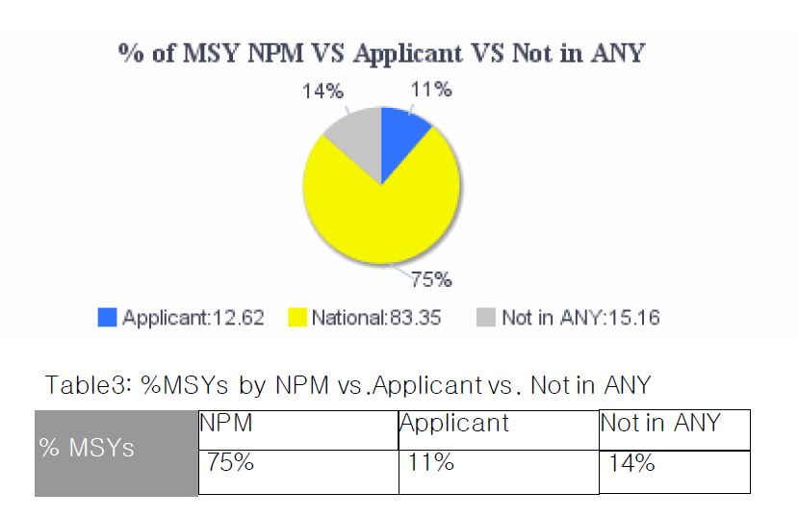
The configuration above meets the AmeriCorps requirement to have one aligned performance measure (output + outcome) corresponding to the primary intervention. Programs are not required to allocate 100% of their MSYs and members to National Performance Measures, or to any performance measures at all.

Appendix B: Performance Measures Checklist

This checklist is used to assess performance measures during the review process. Items on the checklist are common problems that require resolution but do not represent a comprehensive list. Refer to the Performance Measure Instructions for full requirements.

Checklist Item |  | Primary Aligned Measure (required) | Additional Measure  (optional) | Additional Measure  (optional)
Resource Allocation
1 | MSY and member allocations to focus areas and objectives are consistent with the application narrative/logic model.
2 | MSY and member allocations to performance measures are consistent with the application narrative/logic model.
Performance Measure Requirements
3 | The application includes at least 1 aligned performance measure (output + outcome) corresponding to the primary intervention.
4 | All performance measures reflect significant program activities whose outputs and outcomes are consistent with the applicant’s core theory of change.
5 | Any output-only measures included in the application consist solely of National Performance Measure outputs.
6 | The application does not include applicant-determined measures that duplicate existing National Performance Measures. (Note: Applicant-determined measures are recognizable by the labels OUTPT or OUTCM, followed by numbers. Any applications containing these labels are NOT National Performance Measures, even if the applicant has labeled them like a national measure.)
Interventions
7 | Interventions are consistent with the program design and contribute directly to the outputs and outcomes.
8 | The application does not include user-defined intervention labels that duplicate existing system-defined intervention categories.
Output Quality
9 | Outputs clearly specify what is counted.
10 | Outputs count only program beneficiaries, not National Service Participants.
Outcome Quality and Alignment
11 | Outcomes are logically aligned with the outputs.
12 | Outcomes reflect a meaningful change in knowledge, attitude, behavior or condition for program beneficiaries. (Note: completion of a program would be considered an output, not an outcome.)
13 | Outcomes can be measured during a single grant year.
Targets
14 | Output and outcome targets are reasonable for the proposed program design.
15 | Targets are expressed as numbers, not percentages.
Performance Measure Instructions
16 | National Performance Measures conform to selection rules, definitions, and data collection requirements specified in the Performance Measure Instructions.
17 | The application does not include any retired National Performance Measures (e.g., measures that do not appear in the Performance Measure Instructions).
Data Collection/Instruments
18 | Data collection methods are appropriate for the output/outcome being measured.
Sampling (if applicable)
19 | If sampling is proposed, the sampling plan is forwarded to AmeriCorps for consideration. (Note: Formula grantees are not permitted to sample.)

Appendix C: Frequently Asked Questions

- What should a continuation applicant do if one or more of their National Performance Measures is no longer present in the Performance Measure Instructions?

All applicants, including continuation applicants, must follow the National Performance Measure selection rules specified in the current Performance Measure Instructions. Applicants must revise their performance measures as needed to conform to the updated instructions.

- What should a continuation grantee who is measuring a National Performance Measure output or outcome that has a changed definition do in the continuation application?

If the grantee is unable to measure the output or outcome as defined in the current Performance Measure Instructions, the grantee should choose a different performance measure.

- What are National Performance Measures?

AmeriCorps has established six Focus Areas: Disaster Services, Economic Opportunity, Education, Environmental Stewardship, Healthy Futures, and Veterans and Military Families based on the priorities included in the Serve America Act. Within these Focus Areas, as well as for Capacity Building, AmeriCorps has created National Performance Measures in order to aggregate the results of similar programs and demonstrate the impact across our agency programs and initiatives.

- What is an aligned performance measure?

An aligned performance measure is an output paired with an outcome. The paired output-outcome measures may be National Performance Measures, applicant-determined measures, or the combination of a National Performance Measure output and an applicant-determined outcome. Applicant-determined outputs cannot be paired with National Performance Measure outcomes in an aligned performance measure.

- What is an applicant-determined performance measure?

An applicant-determined performance measure is one in which the applicant creates the language for the outputs and/or outcomes that will be measured. This is different from the National Performance Measures, where AmeriCorps pre-determines common outputs and outcomes that are available for applicants to use.

- What is an output-only performance measure?

An output-only measure is a National Performance Measure output without associated outcome(s). Applicants may select output-only measures if the output measures a significant program activity. These do not fulfill the requirement for an aligned performance measure, but may be selected in addition to the aligned measure(s).

- What is the definition of "National Service Participant"?

For AmeriCorps State and National programs, National Service Participant refers to the AmeriCorps members themselves.

- Can I count AmeriCorps members as beneficiaries of service under my performance measures?

No. Effective starting in 2019 for all applicants (new, recompete, and continuation), AmeriCorps members and other National Service Participants may not be counted as beneficiaries under either National Performance Measures or applicant-determined measures. Some member-focused outputs and outcomes may be reported as Performance Data Elements on annual Progress Reports.

- Do the AmeriCorps members in my program have to be directly providing the service counted in the performance measures?

The activities associated your performance measures must be carried out either by National Service Participants or by volunteers directly recruited and/or supported by National Service Participants.

- How many performance measures should I propose?

Each program must have at least one aligned measure (composed of an output and an outcome) reflecting its primary intervention. It is appropriate to have additional performance measures for other significant components of your program, but AmeriCorps values the quality of performance measures more than the quantity. Performance measures reflecting activities that are not central to your program model should not be included in your application and do not need to be reported to AmeriCorps, although you might still collect the data for your own purposes.

- Can I count the same beneficiaries in more than one performance measure output?

Unless otherwise specified, the same beneficiaries may be counted more than once across different measures for different interventions (services) they may be receiving. For example, if your AmeriCorps members helped one specific individual to both prepare for a disaster and obtain employment, you may count that same individual in both D1A and O1A. However, programs cannot count the same individual more than once within any one specific performance measure. So, for example, an individual who attended two disaster preparation training workshops during a single program year cannot be counted twice under D1A.

- Do all beneficiaries counted under a particular performance measure have to receive the same interventions?

Yes, the interventions associated with the measure need to be applicable to all of the beneficiaries counted under the measure, even if the details of the intervention (e.g., the exact dosage provided) may vary. If one set of beneficiaries is receiving one type of intervention (e.g., mentoring) and a different set of beneficiaries is receiving a different type of intervention (e.g., tutoring), the two sets of beneficiaries should be counted in separate performance measures even if the expected outcome is the same. In contrast, if all beneficiaries are receiving multiple interventions with the same expected outcome (e.g. all beneficiaries are being both mentored and tutored to improve their academic performance), they can be counted in a single performance measure.

- Can one performance measure output have more than one outcome?

Yes, there may be more than one outcome measure associated with a single output. Aligned measures should only be configured this way if it is expected that all of the individuals counted in the output will potentially achieve the outcomes indicated. If the outcomes are resulting from different populations being served, they should be counted in distinct performance measures.

- Can I count the same people more than once under one performance measure output or outcome if they receive service in more than one grant year?

If the individual receives services in more than one grant year, they may be counted as having received services in the output measure for each of the grant years in which they receive services. They may only be counted in the outcome measure for each grant year if they meet the specified level of improvement for the outcome in each year. For example, a student receives tutoring in second and third grade. The program expects that students will improve their reading score by one grade level each year. If the student is served in both second and third grade and improves by one grade level in each year, the student may be counted in output ED1A and outcome ED5A for both years. If the student improves by ½ grade level in second grade and one grade level in third grade, the student may be counted in ED1A for both years but only in ED5A for the third-grade year.

- Am I allowed to allocate funds for collecting and analyzing data? If so, how much?

Costs related to measuring the performance of a program are allowable grant expenses. There is no standard recommended amount. As with all grant expenditures, these costs must be reasonable, allowable for the proposed program, and properly allocated across grant activities.

- Is my program expected to monitor member time to ensure that it corresponds to what is entered into the Performance Measures Module for the focus areas and strategic plan objectives?

Applicants should enter MSYs and members according to the distribution of time that members are expected to engage in each focus area and strategic plan objective. Programs will not be required to report on how the members actually spent their time. MSY allocations in the application should present the program’s best estimate.

- On the logic model chart there are three outcome levels (short, medium and long). Should all of these outcomes be entered as performance measures?

A program may have a theory of change that is based on accomplishing a long-term change in condition that is not measurable in a single program year. However, there may be shorter-term changes that can be linked to this ultimate goal that are strong indicators that the long-term change is likely to happen. While all of these outcomes may be included in the logic model, grantees are not required to measure or report on all of the outcomes. For performance measurement purposes, outcomes must measure changes that can be observed within a single program year.

- The National Performance Measure I want to select doesn’t appear in the drop-down menu. What should I do?

Only performance measures corresponding to objectives selected on the Objectives tab will appear in the drop-down menu. Refer to the Performance Measure selection rules to determine which objective to select for each performance measure. Do NOT create an applicant-determined measure that duplicates a National Performance Measure.

- I want to create an applicant-determined measure, but the Performance Measures Module isn’t allowing me to do that. What should I do?

There are some objectives for which the creation of applicant-determined outputs is not allowed. These include the Capacity Building and Leverage objective (Capacity Building focus area), the Find Opportunity objective (Economic Opportunity focus area), the Teacher Corps objective (Education focus area), the Green Jobs objective (Environmental Stewardship focus area), and the Access & Attract objective (Veterans and Military Families focus area). For the Capacity Building and Leverage objective, only National Performance Measure outputs are allowed to be used. For the Find Opportunity, Teacher Corps, Green Jobs, and Access & Attract objectives, programs are not allowed to create performance measures.

- I am required to have a performance measure associated with my primary intervention, but I am not able to create a performance measure for the primary intervention I have selected. What should I do?

Since the Find Opportunity, Teacher Corps, Green Jobs, and Access & Attract objectives are member-focused rather than beneficiary-focused, programs are not allowed to create performance measures under these objectives (see FAQ 9). If your primary intervention is connected to one of those objectives, you will need to go back and select a different primary intervention under a different objective. You can retain the member-focused objective as secondary.

- Under what circumstances is it ok for grantees to use sampling to measure outputs and outcomes?

Methodologically speaking, sampling is appropriate for competitive grantees as long as the grantee has a solid plan for ensuring that its sample will be representative. Practically speaking, we would want grantees to use sampling only when they are able to make the case that it is unrealistic to collect data from the whole population. Formula grantees, with rare exceptions granted by AmeriCorps, are not permitted to sample.

- When would AmeriCorps not allow sampling?

AmeriCorps will not allow sampling when it is reasonable to expect a grantee to collect data from the whole population. AmeriCorps will also not allow sampling if the grantee’s sampling frame is not sufficient or if the grantee’s methodology will not result in a representative sample.

- How does a grantee set targets when it is planning to sample?

In most cases the grantee should be able to set targets based on the population as a whole. If a grantee‘s sampling methodology is sound and results in a representative sample, then the program can extrapolate their results to report on an outcome for the population as a whole. For example, a program reports an output of 1000 children served. The program selects a representative sample of 200 children. Of these, 180 students (90%) demonstrate the desired change. In this case, the program could report an extrapolated outcome of 900 students.

- How do I request permission to sample?

A detailed sampling plan must be forwarded to AmeriCorps for consideration. Please consult the Notice of Funding Opportunity or your Portfolio Manager for instructions on how to submit additional documents.

